|  |  |
| --- | --- |
| EGC_Black | Student Name \_\_\_\_\_\_\_\_\_\_\_\_\_\_\_\_\_\_\_\_\_\_\_    **Eastern Goldfields College**  Mathematics 2015  Test 6 (U2 T3) – Calculator Free1 |
|  | **Total Marks: 28 marks** |

**Time allowed: 30 minutes**

**No calculator or notes permitted for this section.**

***Answer all of the following questions. Show all working to obtain full marks.***

**Question 1** **(5 marks: 1, 2, 2)**

1. The random variable X is normally distributed with a mean of 45g and a standard deviation of 4g.
   1. Determine P(X < 41).
   2. Given P(45 – *x* < X < 45 + *x*) = 0.997, find the value of *x*.
   3. Determine the quantile when the mass is 49g.

**Question 2 (4 marks)**

The diagram below shows two triangles: ΔABC is a right triangle and ΔXYZ is a non−right triangle. The diagram is not drawn to scale.

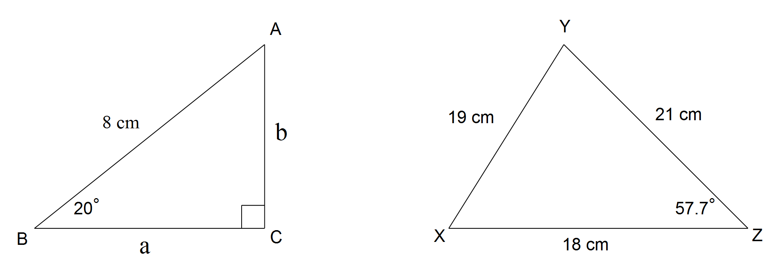

Consider the six statements (A, B, C, D, E and F) that follow. Two of the statements are correct, but four of these statements contain an error.

For each incorrect statement rewrite the statement to make it correct.

Statement A a2 − b2 = 64



Statement B tan70° =

Statement C ∠Y is the largest angle in ΔXYZ

Statement D Area ΔXYZ = ×18×19×sin57.7°



Statement E cosX =



Statement F sin20° =

**Question 3 (3 marks: 1, 1, 1)**

For each of the following, draw the triangle that corresponds with the given information:

(a) 

(b) 

(c) 

Question 4 (6 marks: 3, 3)

(a) In triangle, cm,  and .

Determine the length of side.

(b) In triangle,cm, cm and cm.

Determine the value of .

Question 5 (4 marks)

Solve the following pair of simultaneous equations:

$2x+3y=1$

$x-y=18$

Question 6 (6 marks: 5, 1)

a) The table below shows data about four different tests. Complete the table below:

|  |  |  |  |  |
| --- | --- | --- | --- | --- |
| **Test** | **Score** | **Standardised Score** | **Mean** | **Standard deviation** |
| 1 | 10 |  | 8 | 2 |
| 2 | 6 |  | 12 | 2 |
| 3 |  | 2 | 15 | 2.5 |
| 4 | 10 | -0.8 |  | 3 |

b) Order the student’s performance in the four tests from best to worst.

**End of Non-Calculator Section**

|  |  |
| --- | --- |
| EGC_Black | Student Name \_\_\_\_\_\_\_\_\_\_\_\_\_\_\_\_\_\_\_\_\_\_\_    **Eastern Goldfields College**  Mathematics 2015  Test 6 (U2 T3) – Calculator Assumed1 |
|  | **Total Marks: 34 marks** |

**Time allowed: 35 minutes**

***Answer all of the following questions. Show all working to obtain full marks.***

**Question 1** **(10 marks: 2 each)**

Suppose a factory produces Freddo frogs, and they are normally distributed with a mean mass of 35g and a standard deviation of 2g.

* 1. What is the probability that a Freddo has a mass of less than 38.5g?
  2. If the probability of a Freddo being greater than a mass of *q* is 0.8, find *q*

0.25% of all the Freddo’s produced are discarded because they are underweight.

* 1. What is the lightest mass (to the nearest g) a Freddo can be before being discarded?
  2. If 2.5 million Freddo’s are produced per day, how many are of the correct mass and can be sold each day (assume exactly 0.25% are underweight)?
  3. The mass of a giant Freddo is normally distributed, with a standard deviation of 3g. If the probability of the mass being less than 42.5g is 0.8, what is the mean weight of a giant Freddo?

Question 2 (6 marks: 2, 2, 2)

In this diagram, all three vertices of the triangle lie on the circumference of a circle of radius 13cm and the diameter of the circle is the side BC. Side AB is 10cm long and side AC is 24cm.



(a) Use the cosine rule to show that the size of angle CAB is 90°.

(b) Calculate the size of angle ACB.

(c) Draw a line from O to A on the diagram above and then find the area of triangle AOC.

**Question 3 [6 marks: 2, 4]**

Ben and Holly each buy tickets for themselves and their families for the elf concert. Ben buys two child’s tickets and four adult tickets and he pays $24. Holly buys three children’s tickets and three adult tickets and she spends $21.

a) Write two equations in terms of, *c,* the price of a child’s ticket and, *a*, the price of an adult ticket, for what each Ben and Holly spent.

b) Solve your equations to determine the cost of each type of ticket.

**Question 4 (4 marks: 2, 2)**

Use the graph on the right, to solve the following linear equations:

a) $y= -\frac{1}{2 }x+2$ and $y= \frac{1}{2}x+4$

b) $5y=2x-15$ and $y=2x+5$

Question 5 (8 marks: 2, 2, 4)

A small plantation of pine trees is bounded by the three sides of triangle ABC shown below. A road runs through the plantation from B to D. The distances AB, AD and DC are 855, 720 and 465 metres respectively and angle BAD is 70 $°$.

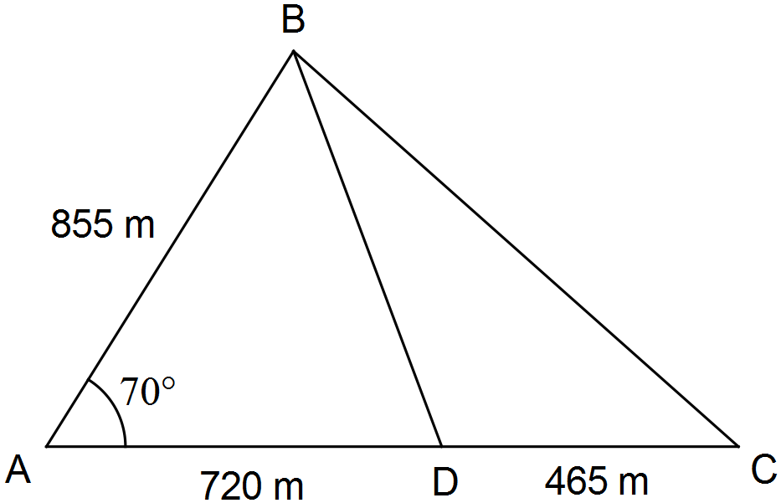

(a) Use trigonometry to determine the length of the road from B to D, rounding your answer to the nearest metre.

(b) Use trigonometry to determine the size of the acute angle ADB, the angle between the road and the southern edge of the plantation.

c) The plantation requires spraying with an insecticide at a cost of 2.8 cents per square metre. Determine the cost of spraying the whole of plantation ABC.

**End of Calculator Section**